User Role Access:
C:\Users\2001666>net group /domain SUZ1-USER-EAST_CM-CASHDATALAKE_DEVOPR
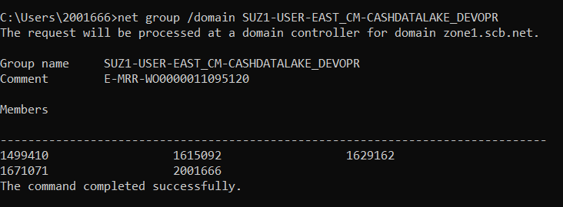

C:\Users\2001666>net group /domain SUZ1-USER-EAST_CM-CASHDATALAKE_OPR
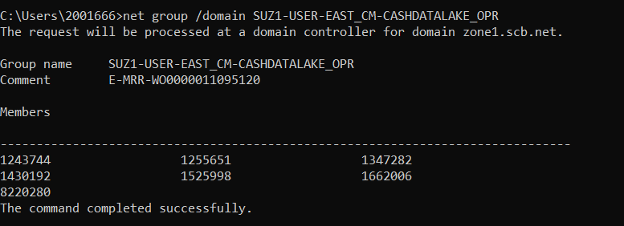
C:\Users\2001666>net group /domain SUZ1-USER-EAST_CM-CASHDATALAKE_BRW
